Geometric Diameter
# Source: AI Source: Provided by: [Data Path: Persons Table -> ID Column: 1, Name_En Column: Motasem Essam] -> From: [ChatGPT] on [7/25/2026]
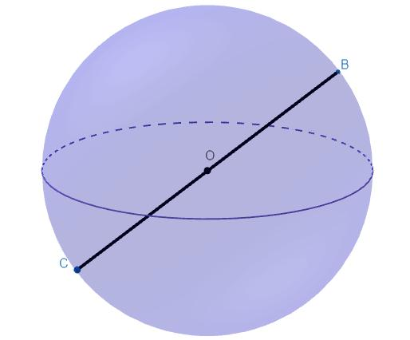
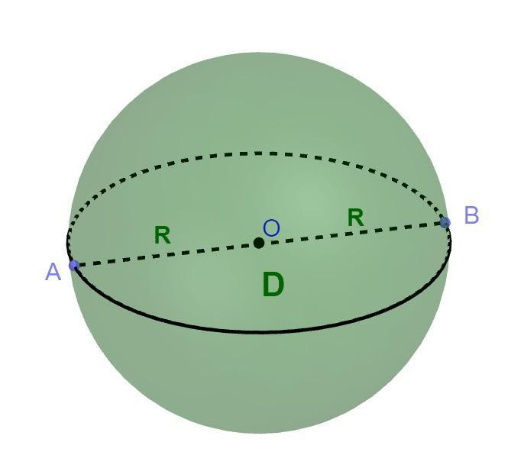
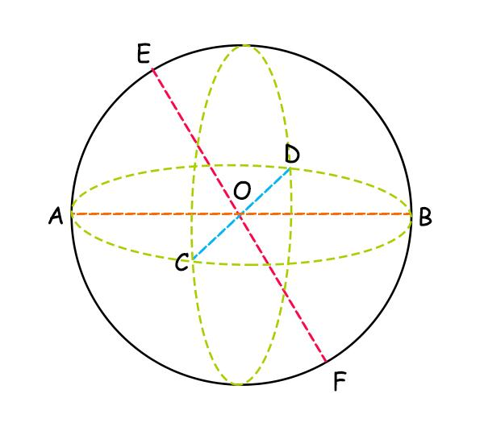

Definition
# Source: AI Source: Provided by: [Data Path: Persons Table -> ID Column: 1, Name_En Column: Motasem Essam] -> From: [ChatGPT] on [7/25/2026]
The geometric diameter of a sphere is a line segment whose endpoints lie on the sphere's surface and whose supporting line passes through the sphere's center.
It represents the maximum straight-line distance between any two points on a perfect sphere's surface.
If $A$ and $B$ are opposite points on the surface and $O$ is the center, then $\overline{AB}$ is a geometric diameter when $A$, $O$, and $B$ are collinear.
$$A ⟷ O ⟷ B$$
Its length is twice the sphere's radius:
$$\boxed{AB=2R}$$

Simple Definition
# Source: AI Source: Provided by: [Data Path: Persons Table -> ID Column: 1, Name_En Column: Motasem Essam] -> From: [ChatGPT] on [7/25/2026]
A geometric diameter is a straight line segment that crosses the center of a sphere and connects two opposite points on its surface.
- First endpoint: A point on the sphere's surface.
- Middle point: The sphere's center.
- Second endpoint: The opposite point on the surface.
- Length: Twice the radius.
- Direction: Any direction through the center.

Geometric Representation
# Source: AI Source: Provided by: [Data Path: Persons Table -> ID Column: 1, Name_En Column: Motasem Essam] -> From: [ChatGPT] on [7/25/2026]
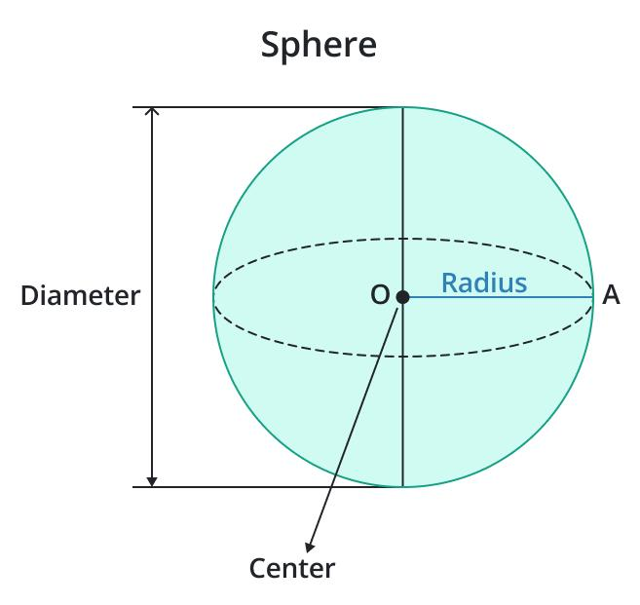
Let a sphere have center $O$, radius $R$, and diameter endpoints $A$ and $B$.
The radius segments are:
$$OA=R, OB=R$$
Because $O$ lies between $A$ and $B$:
$$AB=AO+OB$$
Therefore:
$$\boxed{AB=R+R=2R}$$
The center $O$ is the midpoint of the diameter segment.

Geometric Characteristics
# Source: AI Source: Provided by: [Data Path: Persons Table -> ID Column: 1, Name_En Column: Motasem Essam] -> From: [ChatGPT] on [7/25/2026]
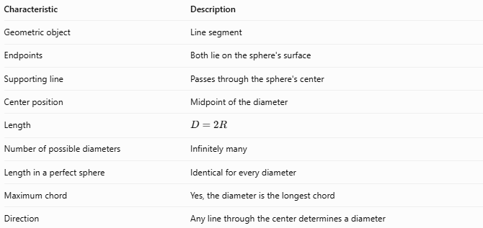
Characteristic | Description
Geometric object | Line segment
Endpoints | Both lie on the sphere's surface
Supporting line | Passes through the sphere's center
Center position | Midpoint of the diameter
Length | $$D=2R$$
Number of possible diameters | Infinitely many
Length in a perfect sphere | Identical for every diameter
Maximum chord | Yes, the diameter is the longest chord
Direction | Any line through the center determines a diameter

Types of Geometric Diameter by Orientation
# Source: AI Source: Provided by: [Data Path: Persons Table -> ID Column: 1, Name_En Column: Motasem Essam] -> From: [ChatGPT] on [7/25/2026]
A perfect sphere has no preferred diameter direction. Diameters can be classified by the orientation of the line passing through its center.
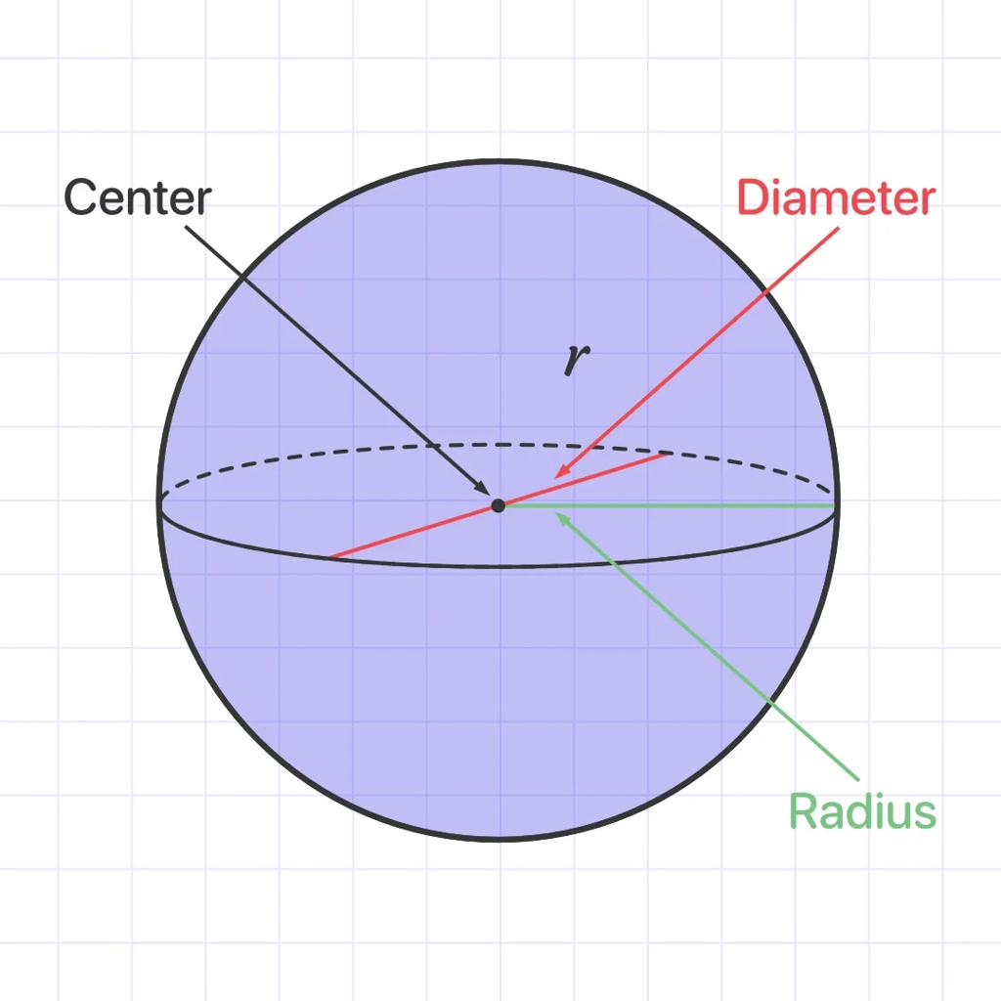

Horizontal Diameter
# Source: AI Source: Provided by: [Data Path: Persons Table -> ID Column: 1, Name_En Column: Motasem Essam] -> From: [ChatGPT] on [7/25/2026]
A diameter drawn horizontally in a chosen diagram or coordinate system.
Its length is \(D=2R\).
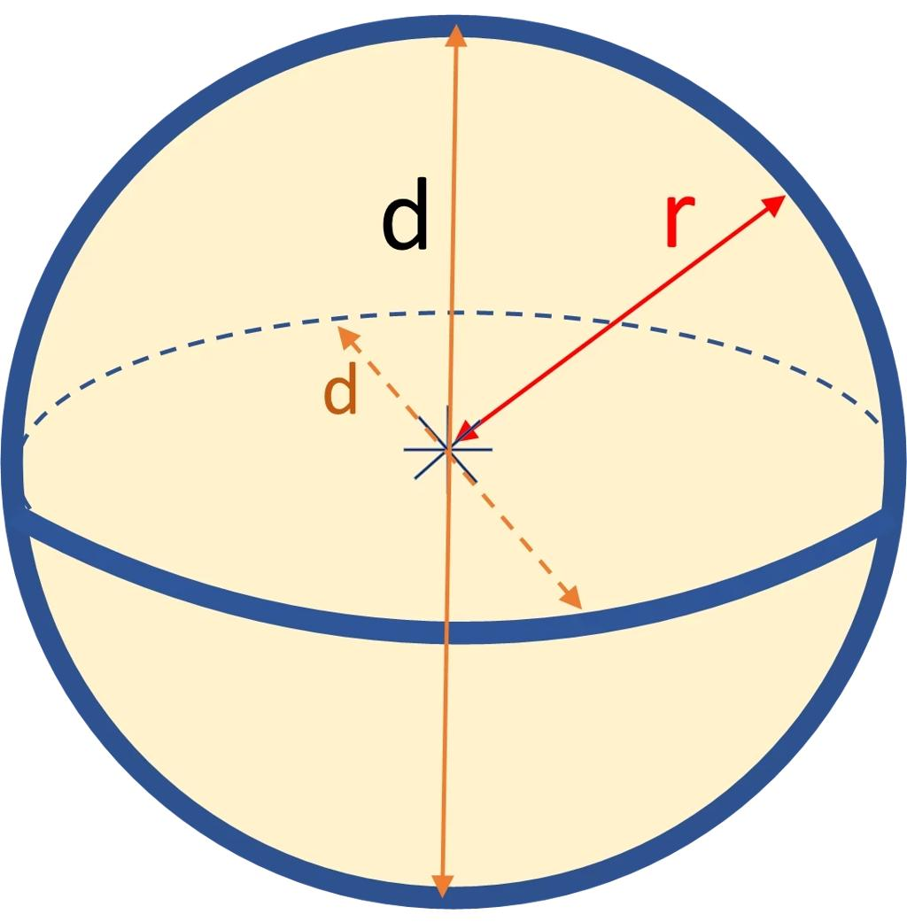

Vertical Diameter
# Source: AI Source: Provided by: [Data Path: Persons Table -> ID Column: 1, Name_En Column: Motasem Essam] -> From: [ChatGPT] on [7/25/2026]
A diameter drawn vertically in a chosen diagram.
Its length is also $D=2R$.
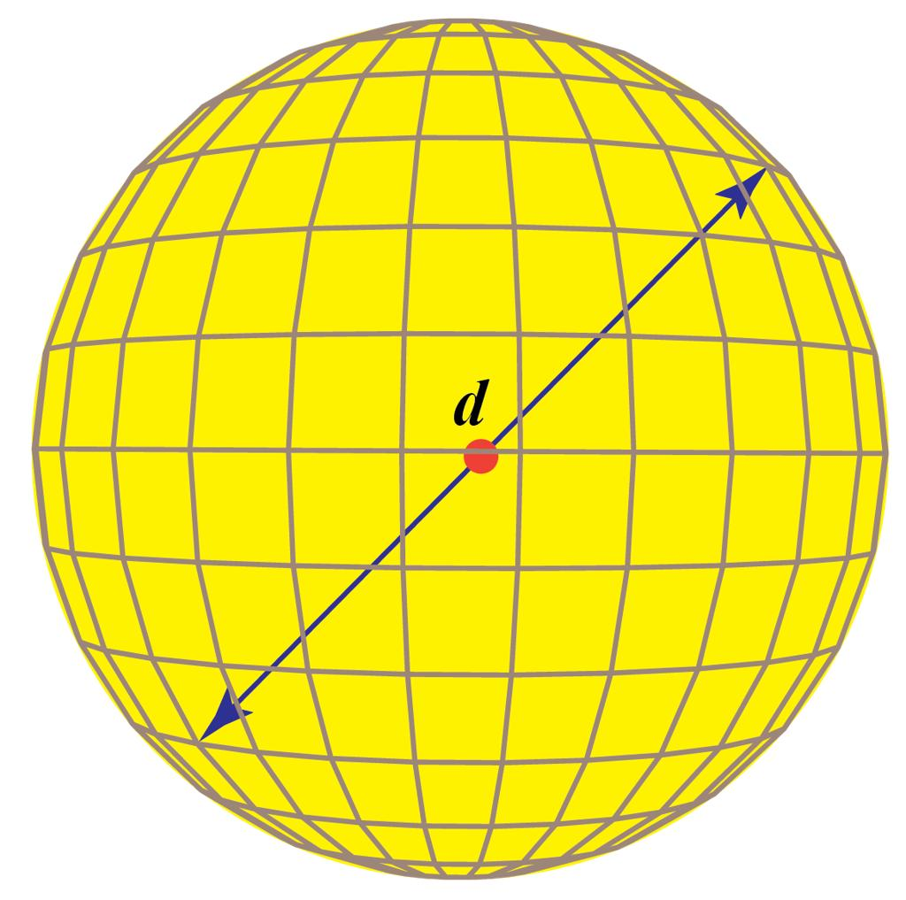

Diagonal Diameter
# Source: AI Source: Provided by: [Data Path: Persons Table -> ID Column: 1, Name_En Column: Motasem Essam] -> From: [ChatGPT] on [7/25/2026]
A diameter drawn at an oblique angle relative to the chosen horizontal and vertical directions.
Its length remains $D=2R$.
These are descriptive orientations, not different mathematical kinds of diameter. Rotating the sphere or changing the coordinate system changes the labels, not the geometry.

Mathematical Formulas

Diameter from Radius
# Source: AI Source: Provided by: [Data Path: Persons Table -> ID Column: 1, Name_En Column: Motasem Essam] -> From: [ChatGPT] on [7/25/2026]
$$\boxed{D=2R}$$
Where:
- $D$ = diameter length.
- $R$ = radius length.

Radius from Diameter
# Source: AI Source: Provided by: [Data Path: Persons Table -> ID Column: 1, Name_En Column: Motasem Essam] -> From: [ChatGPT] on [7/25/2026]
$$\boxed{R=\frac{D}{2}}$$

Diameter from Endpoint Coordinates
# Source: AI Source: Provided by: [Data Path: Persons Table -> ID Column: 1, Name_En Column: Motasem Essam] -> From: [ChatGPT] on [7/25/2026]
If the diameter endpoints are $A\left(x_{1},y_{1},z_{1}\right)$ and $B\left(x_{2},y_{2},z_{2}\right)$, then:
$$\boxed{D=\sqrt{{\left(x_{2}-x_{1}\right)}^{2}+{\left(y_{2}-y_{1}\right)}^{2}+{\left(z_{2}-z_{1}\right)}^{2}}}$$
For the segment to be a diameter, the sphere's center must be the midpoint of $A$ and $B$.

Center from Diameter Endpoints
# Source: AI Source: Provided by: [Data Path: Persons Table -> ID Column: 1, Name_En Column: Motasem Essam] -> From: [ChatGPT] on [7/25/2026]
The center $O$ is:
$$\boxed{O=\left(\frac{x_{1}+x_{2}}{2},\frac{y_{1}+y_{2}}{2},\frac{z_{1}+z_{2}}{2}\right)}$$

Sphere Surface Area and Volume
# Source: AI Source: Provided by: [Data Path: Persons Table -> ID Column: 1, Name_En Column: Motasem Essam] -> From: [ChatGPT] on [7/25/2026]
Using $D=2R$, the surface area can be written as:
$$\boxed{A=πD^{2}}$$
The volume can be written as:
$$\boxed{V=\frac{πD^{3}}{6}}$$

Worked Examples
# Source: AI Source: Provided by: [Data Path: Persons Table -> ID Column: 1, Name_En Column: Motasem Essam] -> From: [ChatGPT] on [7/25/2026]
Example 1 — Finding the Geometric Diameter
A sphere has a radius of $6\text{ cm}$. Find its geometric diameter.
Solution:
$$D=2R$$
$$D=2\left(6\right)$$
$$\boxed{D=12\text{ cm}}$$
Example 2 — Finding the Radius
A sphere has a geometric diameter of $30\text{ m}$. Find its radius.
Solution:
$$R=\frac{D}{2}$$
$$R=\frac{30}{2}$$
$$\boxed{R=15\text{ m}}$$
Example 3 — Finding a Diameter from Coordinates
Two opposite points on a sphere are $A\left(1,2,3\right)$ and $B\left(7,10,3\right)$. Find the diameter length and the center.
Solution:
Calculate the distance between the endpoints:
$$D=\sqrt{{\left(7-1\right)}^{2}+{\left(10-2\right)}^{2}+{\left(3-3\right)}^{2}}$$
$$D=\sqrt{36+64+0}$$
$$\boxed{D=10\text{ units}}$$
Calculate the midpoint:
$$O=\left(\frac{1+7}{2},\frac{2+10}{2},\frac{3+3}{2}\right)$$
$$\boxed{O=\left(4,6,3\right)}$$
The sphere's center is $\left(4,6,3\right)$, and its radius is $5$ units.

Geometric Diameter vs. Related Concepts
# Source: AI Source: Provided by: [Data Path: Persons Table -> ID Column: 1, Name_En Column: Motasem Essam] -> From: [ChatGPT] on [7/25/2026]
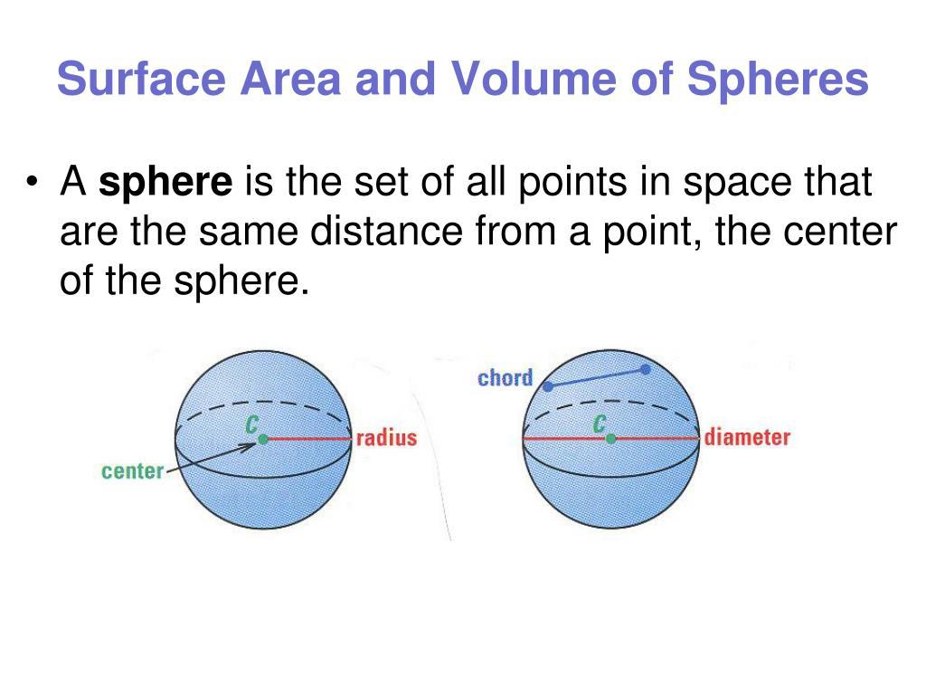
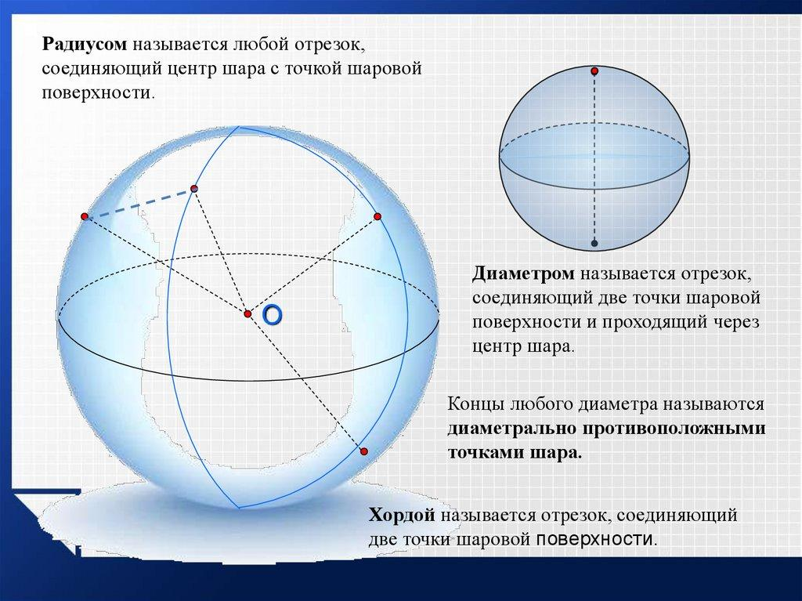
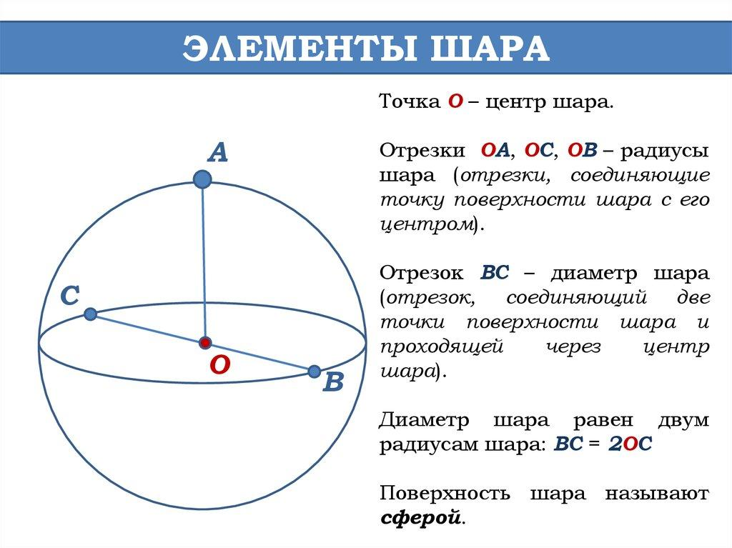
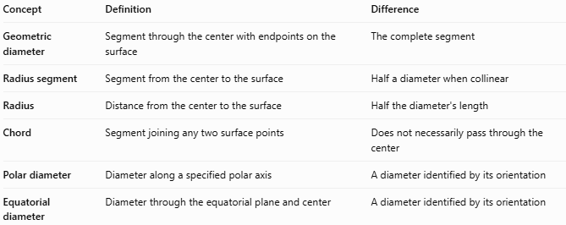
Concept | Definition | Difference
Geometric diameter | Segment through the center with endpoints on the surface | The complete segment
Radius segment | Segment from the center to the surface | Half a diameter when collinear
Radius | Distance from the center to the surface | Half the diameter's length
Chord | Segment joining any two surface points | Does not necessarily pass through the center
Polar diameter | Diameter along a specified polar axis | A diameter identified by its orientation
Equatorial diameter | Diameter through the equatorial plane and center | A diameter identified by its orientation

Applications
# Source: AI Source: Provided by: [Data Path: Persons Table -> ID Column: 1, Name_En Column: Motasem Essam] -> From: [ChatGPT] on [7/25/2026]
Geometric diameter is useful in:
- Geometry: Defining the size of a sphere and proving relationships between radii and chords.
- Engineering: Specifying the dimensions of spherical components.
- Manufacturing: Measuring balls, bearings, and spherical parts.
- Coordinate geometry: Finding a sphere's center and radius from opposite surface points.
- Physics and astronomy: Describing the size of spherical or approximately spherical objects.

Key Points
# Source: AI Source: Provided by: [Data Path: Persons Table -> ID Column: 1, Name_En Column: Motasem Essam] -> From: [ChatGPT] on [7/25/2026]
- A geometric diameter is a segment, not an infinite line.
- Its endpoints lie on the sphere's surface.
- Its supporting line passes through the center.
- The center is the diameter's midpoint.
- Its length is twice the radius: $D=2R$.
- A perfect sphere has infinitely many geometric diameters, all with equal lengths.
- Horizontal, vertical, and diagonal diameters are orientation descriptions rather than distinct mathematical types.

Conclusion
# Source: AI Source: Provided by: [Data Path: Persons Table -> ID Column: 1, Name_En Column: Motasem Essam] -> From: [ChatGPT] on [7/25/2026]
The geometric diameter is a straight segment joining opposite points on a sphere's surface through its center. It is the longest possible chord of a sphere, and every geometric diameter of a perfect sphere has the same length, equal to twice the radius.

